1. Select your folder by clicking right button of your mouse, and select Add to archive option.

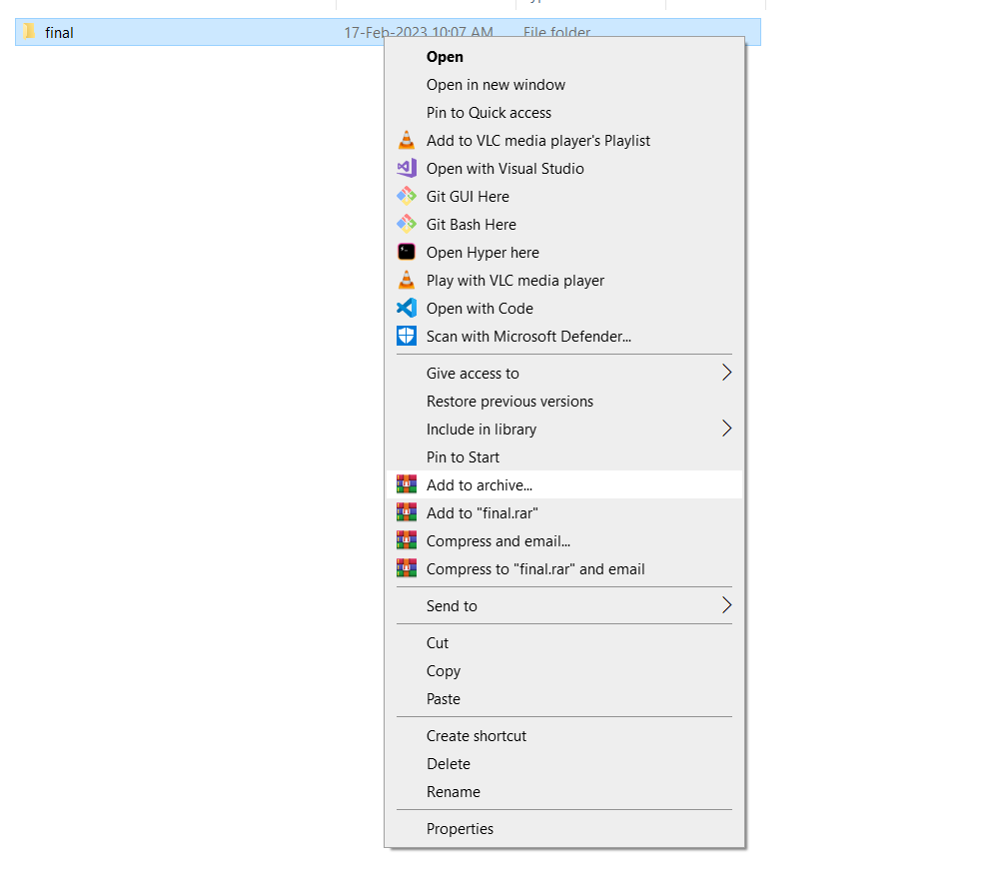

1. Select the .zip option and press ok.

